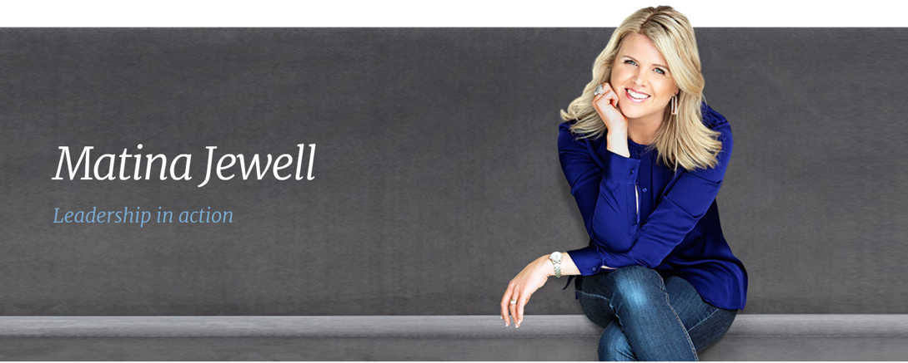

Speaking Engagement Questionnaire

This questionnaire will help Matina tailor a presentation to suit your specific needs.

Key Details

Company:
Function:
Presentation Date:
Contact person:
Contact Phone:
Contact email:

Other Details

- What is the purpose of the function?
- Is there a theme/title for the event? Is there a colour theme for event?
- What is your specific objective(s) for Matina’s presentation?
- What do you hope the audience will gain from the presentation?
- Any sensitive issues to be avoided?
- Any other points you believe would be useful background information?
- Timings for Matina:
  - Suggested arrive time?:
  - Start presentation?:
  - Finish?:
- Who is the Master of Ceremonies (Name & Title please)?
- Number of attendees?
  - Are partners invited?
- Average age of audience:
  - Percentage male/female?:
- General description of the audience:
- Any VIPs/dignitaries attending?
- Who will be the senior people at the function?
- Have professional speakers been used at recent events - who?
- Who else is speaking at this event other than internal staff?
- What format will the room be (eg theatre, classroom, banquet style)?
  - If possible, please send a copy of the floor plan including the stage and screen position.
- Will there be a stage or raised platform?
- Contact for audio visual/tech?
- Screen slide ratio? (eg 16:9, 4:3 etc)
- Will there be a stage monitor (for Matina to view)?
- Dress code (eg business, casual, black tie/formal)?
- Transport arrangements to and from the venue?
- Contact for emergencies (please include mobile phone number)?
- Contact person on arrival at the venue?
- What time will the function area be available for Matina to check equipment?
- To reinforce the impact of Matina’s presentation, many organisations choose to present their delegates with a copy of her book “Caught in the Crossfire”. Special rates apply for bulk orders.
  - Would you like to pre-purchase copies of Matina’s book?
  - Would you like Matina to have copies of her book available to sign and sell at the function?
- If possible, please provide a schedule for the entire function?
- Are there any social media channels for your event that you would like Matina to comment on?
- Any other relevant details?

Please email the completed form directly to: matina@matinajewell.com

Tech Rider: Please note that Matina will require (i) lapel microphone, (ii) projector/screen (preferably set to 16:0) and (iii) loud audio to play video clips in her presentation.

